MAD LAB CYCLES

ROSHMI ROY
S3:MCA
ROLLNO:46
1.Design a login page
XML CODE

<LinearLayout android:layout_width="match_parent"
xmlns:android="http://schemas.android.com/apk/res/android"
android:layout_height="match_parent"
android:orientation="vertical"
>
<EditText
android:layout_width="wrap_content"
android:layout_height="wrap_content"
android:hint="username"
android:layout_gravity="center"
android:id="@+id/et1" />
<TextView
android:id="@+id/tv1"
android:layout_height="wrap_content"
android:layout_width="wrap_content"
android:layout_gravity="center"
/>
<EditText
android:id="@+id/et2"
android:layout_width="wrap_content"
android:layout_height="wrap_content"
android:hint="password"
android:layout_gravity="center"/>
<TextView
android:id="@+id/tv2"
android:layout_height="wrap_content"
android:layout_width="wrap_content"
android:layout_gravity="center"
/>
<Button
android:layout_width="200dp"
android:layout_height="50dp"
android:text="login"
android:id="@+id/b1"
android:onClick="login"
android:layout_gravity="center"
/>
<Button
android:layout_width="200dp"
android:layout_height="50dp"
android:text="cancel"
android:id="@+id/b2"
android:onClick="cancel"
android:layout_gravity="center"
/>
</LinearLayout>

JAVACODE
package com.example.sjcet.myapplication;
import android.support.v7.app.AppCompatActivity;
import android.os.Bundle;
import android.view.View;
import android.widget.Toast;
public class MainActivity extends AppCompatActivity {
@Override
protected void onCreate(Bundle savedInstanceState) {
super.onCreate(savedInstanceState);
setContentView(R.layout.activity_main);
}
public void login(View view) {
Toast.makeText(this, "hello", Toast.LENGTH_SHORT).show();
}
}
OUTPUT
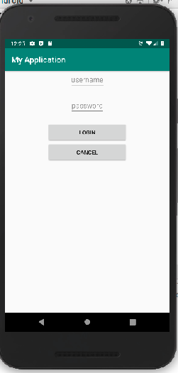

2.change content in the text view in button click

XML CODE
<LinearLayout
android:layout_width="match_parent"
android:layout_height="match_parent"
android:orientation="vertical"
android:gravity="center"
xmlns:android="http://schemas.android.com/apk/res/android">
<TextView
android:id="@+id/tv"
android:layout_width="wrap_content"
android:layout_height="wrap_content"
android:text="roshmi"/>
<Button
android:id="@+id/btn1"
android:layout_width="wrap_content"
android:layout_height="wrap_content"
android:text="Change"
android:onClick="change"/>
</LinearLayout>
JAVACODE
package com.example.sjcet.a2pgm;
import android.support.v7.app.AppCompatActivity;
import android.os.Bundle;
import android.view.View;
import android.widget.TextView;
public class MainActivity extends AppCompatActivity {
TextView tv;
@Override
protected void onCreate(Bundle savedInstanceState) {
super.onCreate(savedInstanceState);
setContentView(R.layout.activity_main);
tv = findViewById(R.id.tv);
}
public void change(View view) {
tv.setText("ROSHMIROY");
}
}
OUTPUT
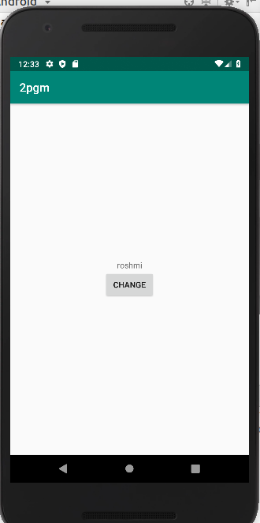
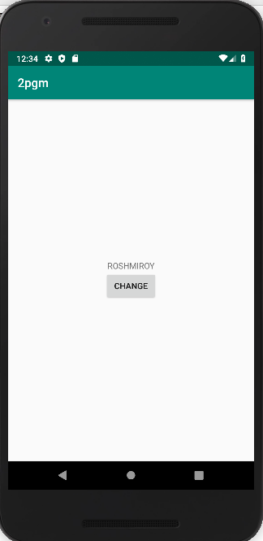

3.Read a content from edit text and print it in a text view.
XML CODE
<LinearLayout android:layout_width="match_parent"
xmlns:android="http://schemas.android.com/apk/res/android"
android:layout_height="match_parent"
android:orientation="vertical">
<EditText
android:layout_width="wrap_content"
android:layout_height="wrap_content"
android:hint="enter your name"
android:layout_gravity="center"
android:id="@+id/et1" />
<TextView
android:id="@+id/tv"
android:layout_width="wrap_content"
android:layout_height="wrap_content"
android:layout_gravity="center"
/>
<Button
android:id="@+id/btn1"
android:layout_width="wrap_content"
android:layout_height="wrap_content"
android:layout_gravity="center"
android:text="display"
android:onClick="display"/>
</LinearLayout>
JAVACODE
package com.example.sjcet.pgm3;
import android.support.v7.app.AppCompatActivity;
import android.os.Bundle;
import android.view.View;
import android.widget.Button;
import android.widget.EditText;
import android.widget.TextView;
public class MainActivity extends AppCompatActivity {
TextView tv;
EditText et1;
Button btn1;
@Override
protected void onCreate(Bundle savedInstanceState) {
super.onCreate(savedInstanceState);
setContentView(R.layout.activity_main);
tv = findViewById(R.id.tv);
et1 =findViewById(R.id.et1);
btn1=findViewById(R.id.btn1);
}
public void display(View view) {
String content = et1 .getText().toString();
tv.setText(content);
}
}
OUTPUT
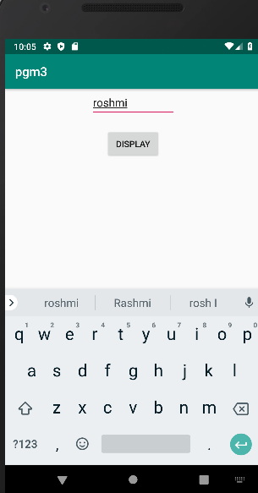
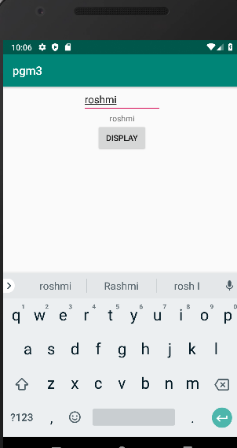

4.change the background color on a button click
XML CODE

<LinearLayout
android:layout_width="match_parent"
android:layout_height="match_parent"
android:orientation="vertical"
android:gravity="center"
xmlns:android="http://schemas.android.com/apk/res/android">
<TextView
android:layout_width="wrap_content"
android:layout_height="wrap_content"
android:id="@+id/tv"
android:gravity="center"
android:text="would you like this"/>
<Button
android:layout_width="wrap_content"
android:layout_height="wrap_content"
android:text="Change"
android:id="@+id/b1"
android:onClick="click"/>
</LinearLayout>

JAVACODE
package com.example.sjcet.pgm14;
import android.support.v7.app.AppCompatActivity;
import android.os.Bundle;
import android.view.View;
import android.widget.Button;
import android.widget.TextView;
public class MainActivity extends AppCompatActivity {
TextView tv;
Button b1;
View v1;
@Override
protected void onCreate(Bundle savedInstanceState) {
super.onCreate(savedInstanceState);
setContentView(R.layout.activity_main);
b1 = findViewById(R.id.b1);
v1 = this .getWindow().getDecorView();
}
public void click(View view) {
v1.setBackgroundResource(android.R.color.holo_blue_dark);
}
}

OUTPUT
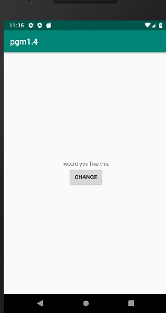
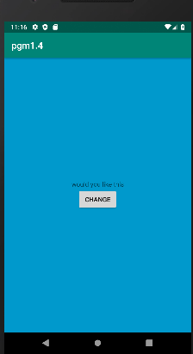

5.create sample calculator
XML CODE
<?xml version="1.0" encoding="utf-8"?>
<RelativeLayout xmlns:android="http://schemas.android.com/apk/res/android"
xmlns:tools="http://schemas.android.com/tools"
android:id="@+id/relative1"
android:layout_width="match_parent"
android:layout_height="match_parent"
tools:context=".MainActivity">
<EditText
android:id="@+id/edt1"
android:layout_width="match_parent"
android:layout_height="wrap_content" />
<Button
android:id="@+id/button1"
style="?android:attr/buttonStyleSmall"
android:layout_width="wrap_content"
android:layout_height="wrap_content"
android:layout_alignEnd="@+id/button4"
android:layout_alignRight="@+id/button4"
android:layout_below="@+id/edt1"
android:layout_marginTop="94dp"
android:text="1" />
<Button
android:id="@+id/button2"
style="?android:attr/buttonStyleSmall"
android:layout_width="wrap_content"
android:layout_height="wrap_content"
android:layout_alignTop="@+id/button1"
android:layout_toLeftOf="@+id/button3"
android:layout_toStartOf="@+id/button3"
android:text="2" />
<Button
android:id="@+id/button3"
style="?android:attr/buttonStyleSmall"
android:layout_width="wrap_content"
android:layout_height="wrap_content"
android:layout_alignTop="@+id/button2"
android:layout_centerHorizontal="true"
android:text="3" />
<Button
android:id="@+id/button4"
style="?android:attr/buttonStyleSmall"
android:layout_width="wrap_content"
android:layout_height="wrap_content"
android:layout_below="@+id/button1"
android:layout_toLeftOf="@+id/button2"
android:text="4" />
<Button
android:id="@+id/button5"
style="?android:attr/buttonStyleSmall"
android:layout_width="wrap_content"
android:layout_height="wrap_content"
android:layout_alignBottom="@+id/button4"
android:layout_alignLeft="@+id/button2"
android:layout_alignStart="@+id/button2"
android:text="5" />
<Button
android:id="@+id/button6"
style="?android:attr/buttonStyleSmall"
android:layout_width="wrap_content"
android:layout_height="wrap_content"
android:layout_alignLeft="@+id/button3"
android:layout_alignStart="@+id/button3"
android:layout_below="@+id/button3"
android:text="6" />
<Button
android:id="@+id/button7"
style="?android:attr/buttonStyleSmall"
android:layout_width="wrap_content"
android:layout_height="wrap_content"
android:layout_below="@+id/button4"
android:layout_toLeftOf="@+id/button2"
android:text="7" />
<Button
android:id="@+id/button8"
style="?android:attr/buttonStyleSmall"
android:layout_width="wrap_content"
android:layout_height="wrap_content"
android:layout_alignLeft="@+id/button5"
android:layout_alignStart="@+id/button5"
android:layout_below="@+id/button5"
android:text="8" />
<Button
android:id="@+id/button9"
style="?android:attr/buttonStyleSmall"
android:layout_width="wrap_content"
android:layout_height="wrap_content"
android:layout_alignLeft="@+id/button6"
android:layout_alignStart="@+id/button6"
android:layout_below="@+id/button6"
android:text="9" />
<Button
android:id="@+id/buttonadd"
style="?android:attr/buttonStyleSmall"
android:layout_width="wrap_content"
android:layout_height="wrap_content"
android:layout_alignEnd="@+id/edt1"
android:layout_alignRight="@+id/edt1"
android:layout_alignTop="@+id/button3"
android:layout_marginLeft="46dp"
android:layout_marginStart="46dp"
android:layout_toRightOf="@+id/button3"
android:text="+" />
<Button
android:id="@+id/buttonsub"
style="?android:attr/buttonStyleSmall"
android:layout_width="wrap_content"
android:layout_height="wrap_content"
android:layout_alignEnd="@+id/buttonadd"
android:layout_alignLeft="@+id/buttonadd"
android:layout_alignRight="@+id/buttonadd"
android:layout_alignStart="@+id/buttonadd"
android:layout_below="@+id/buttonadd"
android:text="-" />
<Button
android:id="@+id/buttonmul"
style="?android:attr/buttonStyleSmall"
android:layout_width="wrap_content"
android:layout_height="wrap_content"
android:layout_alignLeft="@+id/buttonsub"
android:layout_alignParentEnd="true"
android:layout_alignParentRight="true"
android:layout_alignStart="@+id/buttonsub"
android:layout_below="@+id/buttonsub"
android:text="*" />

JAVACODE
package com.example.sjcet.pgm5;
import android.support.v7.app.AppCompatActivity;
import android.os.Bundle;
import android.view.View;
import android.widget.Button;
import android.widget.EditText;
public class MainActivity extends AppCompatActivity {
Button button0, button1, button2, button3, button4, button5, button6,
button7, button8, button9, buttonAdd, buttonSub, buttonDivision,
buttonMul, button10, buttonC, buttonEqual;
EditText crunchifyEditText;
float mValueOne, mValueTwo;
boolean crunchifyAddition, mSubtract, crunchifyMultiplication, crunchifyDivision;
@Override
protected void onCreate(Bundle savedInstanceState) {
super.onCreate(savedInstanceState);
setContentView(R.layout.activity_main);
button0 = (Button) findViewById(R.id.button0);
button1 = (Button) findViewById(R.id.button1);
button2 = (Button) findViewById(R.id.button2);
button3 = (Button) findViewById(R.id.button3);
button4 = (Button) findViewById(R.id.button4);
button5 = (Button) findViewById(R.id.button5);
button6 = (Button) findViewById(R.id.button6);
button7 = (Button) findViewById(R.id.button7);
button8 = (Button) findViewById(R.id.button8);
button9 = (Button) findViewById(R.id.button9);
button10 = (Button) findViewById(R.id.button10);
buttonAdd = (Button) findViewById(R.id.buttonadd);
buttonSub = (Button) findViewById(R.id.buttonsub);
buttonMul = (Button) findViewById(R.id.buttonmul);
buttonDivision = (Button) findViewById(R.id.buttondiv);
buttonC = (Button) findViewById(R.id.buttonC);
buttonEqual = (Button) findViewById(R.id.buttoneql);
crunchifyEditText = (EditText) findViewById(R.id.edt1);
button1.setOnClickListener(new View.OnClickListener() {
@Override
public void onClick(View v) {
crunchifyEditText.setText(crunchifyEditText.getText() + "1");
}
});
button2.setOnClickListener(new View.OnClickListener() {
@Override
public void onClick(View v) {
crunchifyEditText.setText(crunchifyEditText.getText() + "2");
}
});
button3.setOnClickListener(new View.OnClickListener() {
@Override
public void onClick(View v) {
crunchifyEditText.setText(crunchifyEditText.getText() + "3");
}
});
button4.setOnClickListener(new View.OnClickListener() {
@Override
public void onClick(View v) {
crunchifyEditText.setText(crunchifyEditText.getText() + "4");
}
});
button5.setOnClickListener(new View.OnClickListener() {
@Override
public void onClick(View v) {
crunchifyEditText.setText(crunchifyEditText.getText() + "5");
}
});
button6.setOnClickListener(new View.OnClickListener() {
@Override
public void onClick(View v) {
crunchifyEditText.setText(crunchifyEditText.getText() + "6");
}
});
button7.setOnClickListener(new View.OnClickListener() {
@Override
public void onClick(View v) {
crunchifyEditText.setText(crunchifyEditText.getText() + "7");
}
});
button8.setOnClickListener(new View.OnClickListener() {
@Override
public void onClick(View v) {
crunchifyEditText.setText(crunchifyEditText.getText() + "8");
}
});
button9.setOnClickListener(new View.OnClickListener() {
@Override
public void onClick(View v) {
crunchifyEditText.setText(crunchifyEditText.getText() + "9");
}
});
button0.setOnClickListener(new View.OnClickListener() {
@Override
public void onClick(View v) {
crunchifyEditText.setText(crunchifyEditText.getText() + "0");
}
});
buttonAdd.setOnClickListener(new View.OnClickListener() {
@Override
public void onClick(View v) {
if (crunchifyEditText == null) {
crunchifyEditText.setText("");
} else {
mValueOne = Float.parseFloat(crunchifyEditText.getText() + "");
crunchifyAddition = true;
crunchifyEditText.setText(null);
}
}
});
buttonSub.setOnClickListener(new View.OnClickListener() {
@Override
public void onClick(View v) {
mValueOne = Float.parseFloat(crunchifyEditText.getText() + "");
mSubtract = true;
crunchifyEditText.setText(null);
}
});
buttonMul.setOnClickListener(new View.OnClickListener() {
@Override
public void onClick(View v) {
mValueOne = Float.parseFloat(crunchifyEditText.getText() + "");
crunchifyMultiplication = true;
crunchifyEditText.setText(null);
}
});
buttonDivision.setOnClickListener(new View.OnClickListener() {
@Override
public void onClick(View v) {
mValueOne = Float.parseFloat(crunchifyEditText.getText() + "");
crunchifyDivision = true;
crunchifyEditText.setText(null);
}
});
buttonEqual.setOnClickListener(new View.OnClickListener() {
@Override
public void onClick(View v) {
mValueTwo = Float.parseFloat(crunchifyEditText.getText() + "");
if (crunchifyAddition == true) {
crunchifyEditText.setText(mValueOne + mValueTwo + "");
crunchifyAddition = false;
}
if (mSubtract == true) {
crunchifyEditText.setText(mValueOne - mValueTwo + "");
mSubtract = false;
}
if (crunchifyMultiplication == true) {
crunchifyEditText.setText(mValueOne * mValueTwo + "");
crunchifyMultiplication = false;
}
if (crunchifyDivision == true) {
crunchifyEditText.setText(mValueOne / mValueTwo + "");
crunchifyDivision = false;
}
}
});
buttonC.setOnClickListener(new View.OnClickListener() {
@Override
public void onClick(View v) {
crunchifyEditText.setText("");
}
});
button10.setOnClickListener(new View.OnClickListener() {
@Override
public void onClick(View v) {
crunchifyEditText.setText(crunchifyEditText.getText() + ".");
}
});
}
}

OUTPUT

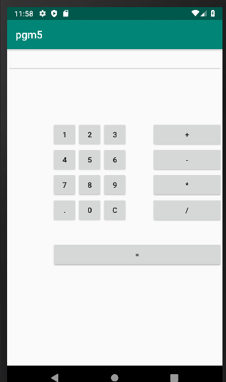
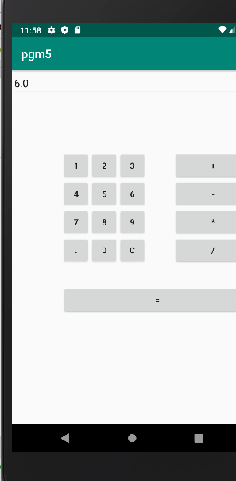

LABCYCLE-2

1.Create two activites from the first activity move to second activity on button click.
Activity main.xml
<LinearLayout android:layout_width="match_parent"
android:layout_height="match_parent"
android:orientation="vertical"
android:gravity="center"
xmlns:android="http://schemas.android.com/apk/res/android">
<Button
android:layout_width="wrap_content"
android:layout_height="wrap_content"
android:text="move"
android:layout_gravity="center"
android:id="@+id/b"
android:onClick="move"/>
</LinearLayout>
mainactivity.java
package com.example.sjcet.cycle21;
import android.support.v7.app.AppCompatActivity;
import android.os.Bundle;
import android.view.View;
import android.content.Intent;
import android.widget.Button;
public class MainActivity extends AppCompatActivity {
Button b;
@Override
protected void onCreate(Bundle savedInstanceState) {
super.onCreate(savedInstanceState);
setContentView(R.layout.activity_main);
b = findViewById(R.id.b);
}
public void move(View view) {
openNewActivity();
}
public void openNewActivity(){
Intent intent = new Intent(this, NewActivity.class);
startActivity(intent);
}
}
activitynew.xml

<LinearLayout android:layout_width="match_parent"
android:layout_height="match_parent"
android:orientation="vertical"
android:gravity="center"
xmlns:android="http://schemas.android.com/apk/res/android">
<TextView
android:layout_width="match_parent"
android:layout_height="match_parent"
android:text="welcome to new activity"
android:gravity="center"/>
</LinearLayout>

newactivity.java
package com.example.sjcet.cycle21;
import android.support.v7.app.AppCompatActivity;
import android.os.Bundle;
public class NewActivity extends AppCompatActivity {
@Override
protected void onCreate(Bundle savedInstanceState) {
super.onCreate(savedInstanceState);
setContentView(R.layout.activity_new);
}
}
Output
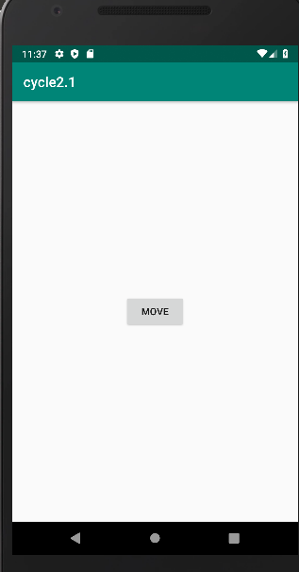
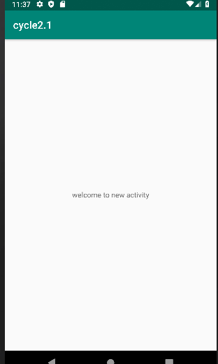

2.Create an activity and move to facebook login page on button click.
Activity main.xml
<LinearLayout android:layout_width="match_parent"
android:layout_height="match_parent"
android:orientation="vertical"
android:gravity="center"
xmlns:android="http://schemas.android.com/apk/res/android">

android:layout_width="wrap_content"
android:layout_height="wrap_content"
android:id="@+id/b1"
android:text="move"
android:onClick="move"/>
</LinearLayout>
mainactivity.java
package com.example.sjcet.facebook;
import android.support.v7.app.AppCompatActivity;
import android.os.Bundle;
import android.view.View;
import android.widget.Button;
import android.net.Uri;
import android.content.Intent;
public class MainActivity extends AppCompatActivity {
Button b1;
@Override
protected void onCreate(Bundle savedInstanceState) {
super.onCreate(savedInstanceState);
setContentView(R.layout.activity_main);
b1= findViewById(R.id.b1);
}
public void move(View view) {
Intent intent = new Intent(Intent.ACTION_VIEW,Uri.parse("https://facebook.com"));
startActivity(intent);
}
}

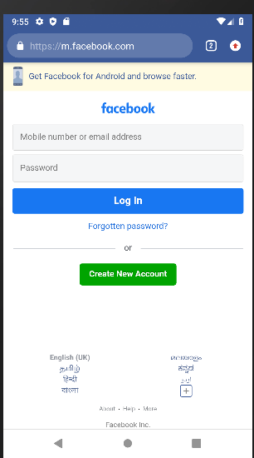
Output
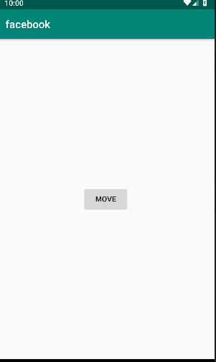

3.Read a message in first activity and pass it to the second activity on a button click.
<LinearLayout
android:layout_height="match_parent"
android:layout_width="match_parent"
android:orientation="vertical"
android:layout_gravity="center"
xmlns:android="http://schemas.android.com/apk/res/android" >
<EditText
android:id="@+id/msg"
android:layout_width="match_parent"
android:layout_height="wrap_content"
android:hint="Enter Message" />
<Button
android:id="@+id/snd"
android:layout_width="wrap_content"
android:layout_height="wrap_content"
android:text="Send"
android:layout_gravity="center"
android:onClick="click"/>
</LinearLayout>
JAVA:
package com.example.sjcet.c2_p2;
import android.content.Intent;
import android.support.v7.app.AppCompatActivity;
import android.os.Bundle;
import android.view.View;
import android.widget.Button;
import android.widget.TextView;
public class MainActivity extends AppCompatActivity {
TextView msg;
Button snd;
@Override
protected void onCreate(Bundle savedInstanceState) {
super.onCreate(savedInstanceState);
setContentView(R.layout.activity_main);
msg=findViewById(R.id.msg);
snd=findViewById(R.id.snd);
}
public void click(View view) {
String str = msg.getText().toString();
Intent intent=new Intent(getApplicationContext(),Main2Activity.class);
intent.putExtra("Message_Key",str);
startActivity(intent);
}
}
XML:
<LinearLayout android:layout_height="match_parent"
android:layout_width="match_parent"
android:orientation="vertical"
xmlns:android="http://schemas.android.com/apk/res/android" >
<TextView
android:id="@+id/rcv"
android:layout_width="match_parent"
android:layout_height="wrap_content"
android:gravity="center"/>
</LinearLayout>
JAVA:
package com.example.sjcet.c2_p2;
import android.content.Intent;
import android.support.v7.app.AppCompatActivity;
import android.os.Bundle;
import android.widget.TextView;
public class Main2Activity extends AppCompatActivity {
TextView rcv;
@Override
protected void onCreate(Bundle savedInstanceState) {
super.onCreate(savedInstanceState);
setContentView(R.layout.activity_main2);
rcv=findViewById(R.id.rcv);
Intent intent = getIntent();
String str = intent.getStringExtra("Message_Key");
// display the string into textView
rcv.setText(str);
}

Output
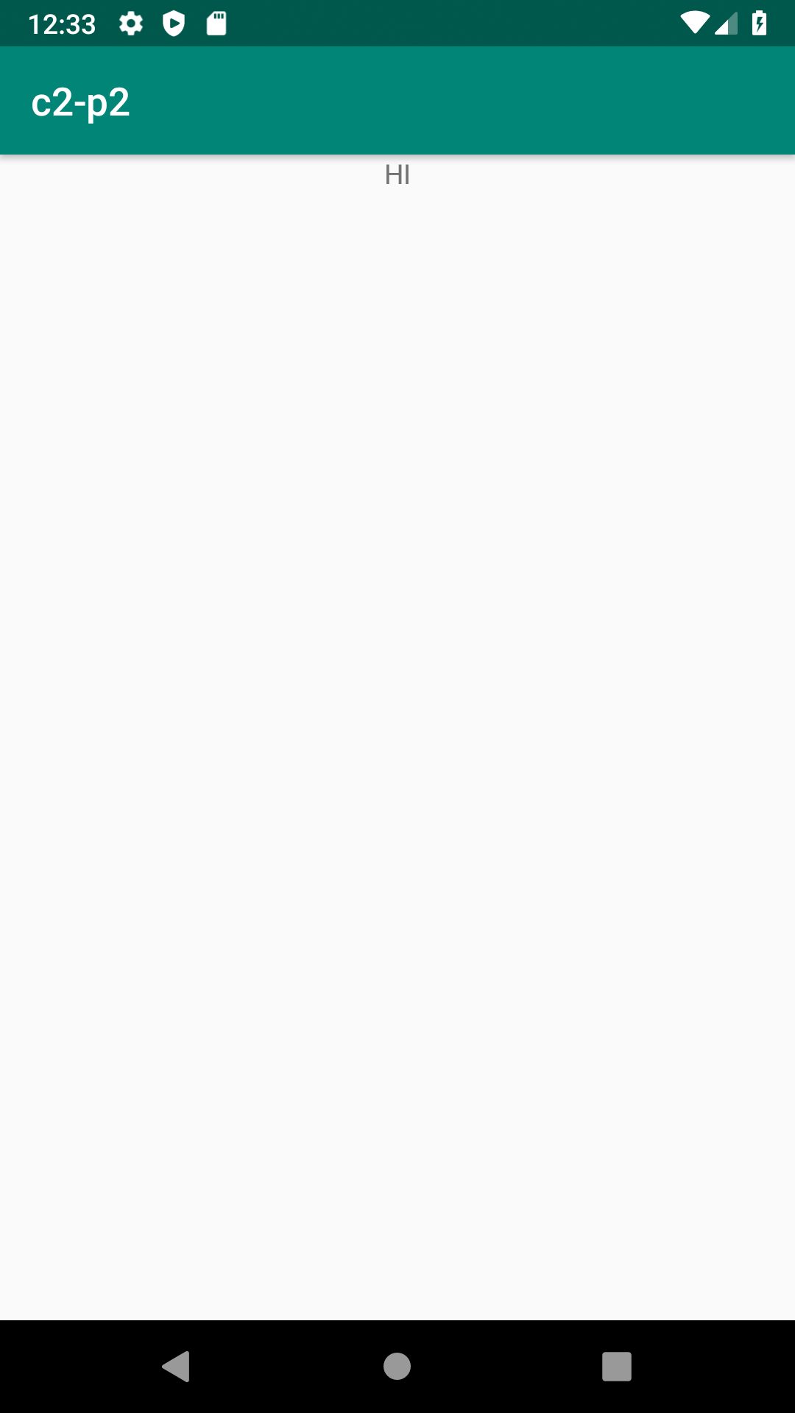
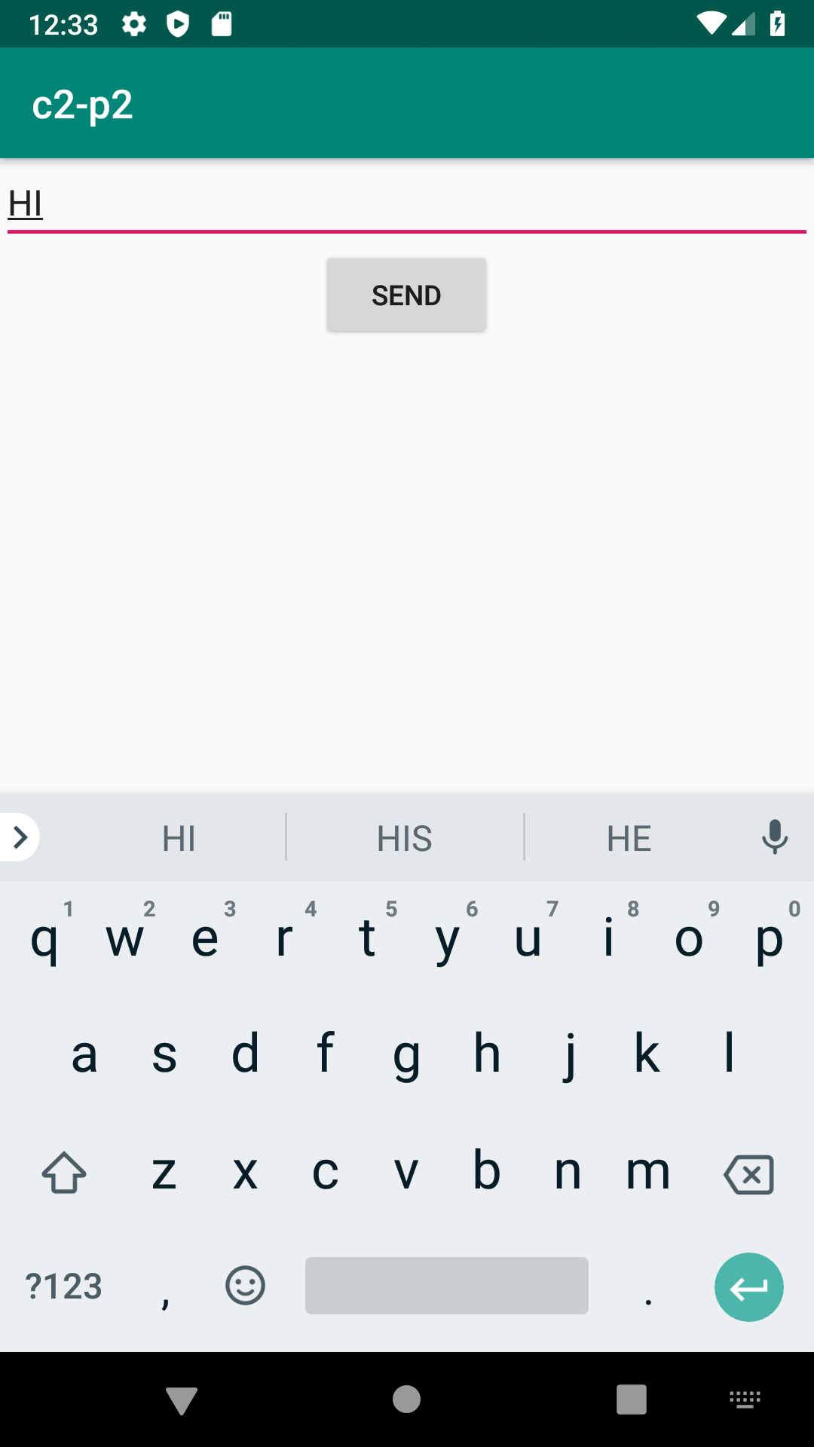

4.Create a registration page with full validation and pass the information to the second activity (using shared preference)

Mandatory fields : fname,lname,gender,email,phone number,password,dob(date picker)

activity.main
<LinearLayout
android:layout_width="match_parent"
android:layout_height="match_parent"
android:orientation="vertical"
xmlns:android="http://schemas.android.com/apk/res/android">
<EditText
android:id="@+id/editTextName"
android:layout_width="match_parent"
android:layout_height="wrap_content"
android:ems="10"
android:hint="Enter First Name"
android:inputType="textPersonName" />
<EditText
android:id="@+id/editTextlName"
android:layout_width="match_parent"
android:layout_height="wrap_content"
android:ems="10"
android:hint="Enter Last Name"
android:inputType="textPersonName" />
<EditText
android:id="@+id/editTextgender"
android:layout_width="match_parent"
android:layout_height="wrap_content"
android:ems="10"
android:hint="Enter Gender"
android:inputType="textPersonName" />
<EditText
android:id="@+id/editTextEmail"
android:layout_width="match_parent"
android:layout_height="wrap_content"
android:ems="10"
android:hint="Enter Email"
android:inputType="textPersonName" />
<EditText
android:id="@+id/editTextMobile"
android:layout_width="match_parent"
android:layout_height="wrap_content"
android:ems="10"
android:hint="Enter Mobile Number"
android:inputType="textEmailAddress" />
<EditText
android:id="@+id/editTextDob"
android:layout_width="match_parent"
android:layout_height="wrap_content"
android:ems="10"
android:hint="Enter Date of Birth (DD/MM/YYYY)"
android:inputType="date" />
<EditText
android:id="@+id/editTextpassword"
android:layout_width="match_parent"
android:layout_height="wrap_content"
android:ems="10"
android:hint="Enter Password"
android:inputType="textPassword" />
<Button
android:id="@+id/buttonSubmit"
android:layout_width="match_parent"
android:layout_height="wrap_content"
android:text="Submit" />
</LinearLayout>
mainactivity.java
package com.example.sjcet.regi;
import android.content.Intent;
import android.net.Uri;
import android.support.v7.app.AppCompatActivity;
import android.os.Bundle;
import android.widget.Button;
import android.widget.EditText;
import android.text.TextUtils;
import android.util.Patterns;
import android.view.View;
import android.widget.DatePicker;
import android.widget.Toast;
import android.content.SharedPreferences;
public class MainActivity extends AppCompatActivity {
EditText editTextName, editTextlName,editTextEmail, editTextMobile,editTextDob, editTextgender,editTextpassword;
Button buttonSubmit;
@Override
protected void onCreate(Bundle savedInstanceState) {
super.onCreate(savedInstanceState);
setContentView(R.layout.activity_main);
buttonSubmit =findViewById(R.id.buttonSubmit);
editTextName =findViewById(R.id.editTextName);
editTextlName =findViewById(R.id.editTextlName);
editTextEmail =findViewById(R.id.editTextEmail);
editTextMobile =findViewById(R.id.editTextMobile);
editTextDob =findViewById(R.id.editTextDob);
editTextgender =findViewById(R.id.editTextgender);
editTextpassword =findViewById(R.id.editTextpassword);
buttonSubmit.setOnClickListener(new View.OnClickListener() {
@Override
public void onClick(View view) {
checkDataEntered();
SharedPreferences mypref=getSharedPreferences("activity_main2.xml",0);
SharedPreferences.Editor editor=mypref.edit();//only write editor
editor.putString("fname",editTextName.getText().toString()); //bundle the data
editor.putString("lname",editTextlName.getText().toString());
editor.putString("gender",editTextgender.getText().toString());
editor.putString("phone",editTextMobile.getText().toString());
editor.putString("pwd",editTextpassword.getText().toString());
editor.putString("email",editTextEmail.getText().toString());
editor.putString("dob",editTextDob.getText().toString());
editor.commit();
// String str = editTextName.getText().toString();
//String str1 = editTextName.getText().toString();
Intent intent = new Intent(getApplicationContext(), Main2Activity.class);
intent.putExtra("fname",editTextName.getText().toString());
intent.putExtra("lname",editTextlName.getText().toString());
intent.putExtra("gender",editTextgender.getText().toString());
intent.putExtra("phone",editTextMobile.getText().toString());
intent.putExtra("pwd",editTextpassword.getText().toString());
intent.putExtra("email",editTextEmail.getText().toString());
intent.putExtra("dob",editTextDob.getText().toString());
startActivity(intent);
}
});
}
boolean isEmail(EditText text) {
CharSequence email = text.getText().toString();
return (!TextUtils.isEmpty(email) && Patterns.EMAIL_ADDRESS.matcher(email).matches());
}
boolean isEmpty(EditText text) {
CharSequence str = text.getText().toString();
return TextUtils.isEmpty(str);
}
void checkDataEntered() {
if (isEmpty(editTextName)) {
Toast t = Toast.makeText(this, "You must enter first name to register!", Toast.LENGTH_SHORT);
t.show();
}
if (isEmpty(editTextlName)) {
editTextlName.setError("Last name is required!");
}
if (isEmpty(editTextMobile)) {
editTextMobile.setError("mobile number is required!");
}
if (isEmpty(editTextgender)) {
editTextgender.setError("Gender is required!");
}
if (isEmpty(editTextpassword)) {
editTextpassword.setError("Password is required!");
}
if (isEmpty(editTextDob)) {
editTextDob.setError("DOB is required!");
}
if (isEmail(editTextEmail) == false) {
editTextEmail.setError("Enter valid email!");
}
}
}
activitymain2.xml
<LinearLayout android:layout_width="match_parent" android:layout_height="match_parent"
android:orientation="vertical"
android:gravity="center"
xmlns:android="http://schemas.android.com/apk/res/android">
<TextView
android:layout_width="match_parent"
android:layout_height="wrap_content"
android:id="@+id/tv"
/>
<TextView
android:layout_width="match_parent"
android:layout_height="wrap_content"
android:id="@+id/tv1"
/>
<TextView
android:layout_width="match_parent"
android:layout_height="wrap_content"
android:id="@+id/tv2"
/>
<TextView
android:layout_width="match_parent"
android:layout_height="wrap_content"
android:id="@+id/tv3"
/>
<TextView
android:layout_width="match_parent"
android:layout_height="wrap_content"
android:id="@+id/tv4"
/>
<TextView
android:layout_width="match_parent"
android:layout_height="wrap_content"
android:id="@+id/tv5"
/>
<TextView
android:layout_width="match_parent"
android:layout_height="wrap_content"
android:id="@+id/tv6"
/>
</LinearLayout>
main2activity.java
package com.example.sjcet.regi;
import android.content.SharedPreferences;
import android.content.Intent;
import android.support.v7.app.AppCompatActivity;
import android.os.Bundle;
import android.widget.TextView;
public class Main2Activity extends AppCompatActivity {
TextView tv,tv1,tv2,tv3,tv4,tv5,tv6;
@Override
protected void onCreate(Bundle savedInstanceState) {
super.onCreate(savedInstanceState);
setContentView(R.layout.activity_main2);
tv = findViewById(R.id.tv);
tv1 =findViewById(R.id.tv1);
tv2 =findViewById(R.id.tv2);
tv3 =findViewById(R.id.tv3);
tv4 =findViewById(R.id.tv4);
tv5 =findViewById(R.id.tv5);
tv6 =findViewById(R.id.tv6);
Intent intent = getIntent();
SharedPreferences mypref=getSharedPreferences("activity_main2.xml",0);
String str = mypref.getString("fname",null);
String str1 = mypref.getString("lname",null);
String str2 = mypref.getString("gender",null);
String str3 = mypref.getString("phone",null);
String str4 = mypref.getString("pwd",null);
String str5 = mypref.getString("email",null);
String str6 = mypref.getString("dob",null);
tv.setText(str);
tv1.setText(str1);
tv2.setText(str2);
tv3.setText(str3);
tv4.setText(str4);
tv5.setText(str5);
tv6.setText(str6);
}
}

Output
